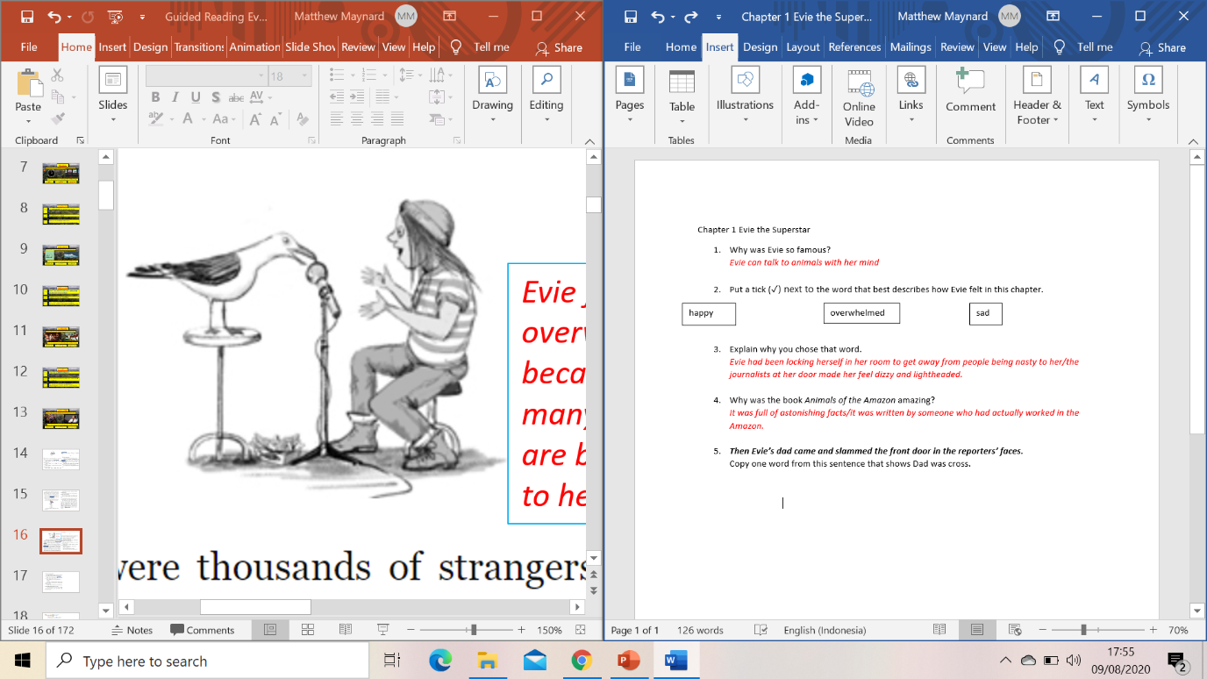Chapter 1 Evie the Superstar

1. Why was Evie so famous?
2. Put a tick (✓) next to the things that Evie had done with her talent. The first one has been done for you:

|  |  |
| --- | --- |
| communicating with dolphins | ✓ |
| getting mice to march in a line |  |
| having tea with a squirrel |  |
| conducting an interview with a seagull |  |
| teaching a dog to speak |  |

1. Who was at Evie’s front door?
2. Put a tick (✓) next to the word that best describes how Evie felt in this chapter.

happy

overwhelmed

sad

1. Explain why you chose that word.
2. Why was the book *Animals of the Amazon* amazing?
3. ***Then Evie’s dad came and slammed the front door in the reporters’ faces.***

Copy one word from this sentence that shows Dad was cross.

1. Would you like to have Evie’s special talent for communicating with animals? Explain your answer.

Answers Chapter 1 Evie the Superstar

1. Why was Evie so famous?

*Evie can talk to animals with her mind*

1. Put a tick (✓) next to the things that Evie had done with her talent. The first one has been done for you:

|  |  |
| --- | --- |
| communicating with dolphins | ✓ |
| getting mice to march in a line | ✓ |
| having tea with a squirrel |  |
| conducting an interview with a seagull | ✓ |
| teaching a dog to speak |  |

1. Who was at Evie’s front door?

*Photographers and journalists.*

1. Put a tick (✓) next to the word that best describes how Evie felt in this chapter.

happy

overwhelmed

sad

1. Explain why you chose that word.

*Evie had been locking herself in her room to get away from people being nasty to her/the journalists at her door made her feel dizzy and lightheaded.*

1. Why was the book *Animals of the Amazon* amazing?

*It was full of astonishing facts/it was written by someone who had actually worked in the Amazon.*

1. ***Then Evie’s dad came and slammed the front door in the reporters’ faces.***

Copy one word from this sentence that shows Dad was cross.

***slammed***

1. Would you like to have Evie’s special talent for communicating with animals? Explain your answer.